**DAILY ONLINE ACTIVITIES SUMMARY**

|  |  |  |  |  |  |  |  |  |
| --- | --- | --- | --- | --- | --- | --- | --- | --- |
| **Date:** | **18/07/2020** | | | | | **Name:** | **NAIPUNYA VINOD NAIK** | |
| **Sem & Sec** | **IV SEM & A SECTION** | | | | | **USN:** | **4AL18CS050** | |
| **Online Test Summary** | | | | | | | | |
| **Subject** | | **1)MATHS IMPROVEMENT TEST_4 (IMPROVEMENT)**  **2) MATHS IMPROVEMENT TEST_2(IMPROVEMENT)**  **3) MATHS IMPROVEMENT TEST (REIMPROVEMENT)** | | | | | | |
| **Max. Marks** | | **1)30**  **2)10**  **3)30** | | **Score** | | | **1) 18**  **2) 7**  **3) 16** | |
| **Certification Course Summary** | | | | | | | | |
| **Course** | 1. **THE ABSOLUTE BEGINNERS GUIDE TO CYBERSECURITY PART-1** 2. **LEARN R-PROGRAMMING FOR MACHINE LEARNING AND DATA SCIENCE** 3. **ANDROID MALWARE ANALYSIS FROM ZERO TO HERO** 4. **WEBINAR ON BLOCKCHAIN TECHNOLOGY PERSPECTIVE** 5. **GOOGLE CLOUD PLATFORM BIG DATA AND MACHINE LEARNING FUNDAMENTALS** | | | | | | | |
| **Certificate Provider** | | | **1)UDEMY**  **2)UDEMY**  **3)UDEMY**  **4)BVICAM**  **5) COURSERA** | | **Duration** | | | **1) 2 HRS**  **2) 36 MIN**  **3) 1.5 HRS**  **4) 2 HRS**  **5) 2 WEEKS** |
| **Coding Challenges** | | | | | | | | |
| **Problem Statement: 1)** [Reverse words in a given String in Python We are given a string and we need to reverse words of given string ?](https://github.com/orgs/alvas-education-foundation/teams/2nd-year/discussions/151) | | | | | | | | |
| **Status: EXECUTED** | | | | | | | | |
| **Uploaded the report in Github** | | | | | **YES** | | | |
| **If yes Repository name** | | | | | <https://github.com/naipunya-naik/lockdown-coding/blob/master/PYTHON%20CODING/reversestring_18-07-2020.py> | | | |
| **Uploaded the report in slack** | | | | | **YES** | | | |

Online Test Details: (Attach the snapshot and briefly write the report for the same).

* THE MATHS IMPROVEMENT TEST_4 WAS CONDUCTED ON 18 JULY 2020
* SYLLABUS:- MODULE 2
* NO OF QUESTIONS:- 15
* TOTAL MARKS:- 30
* EACH QUESTION CARRIED 2 MARKS
* TEST DURATION:- 1.5 HRS
* FROM 3 TO 4.30 PM
* 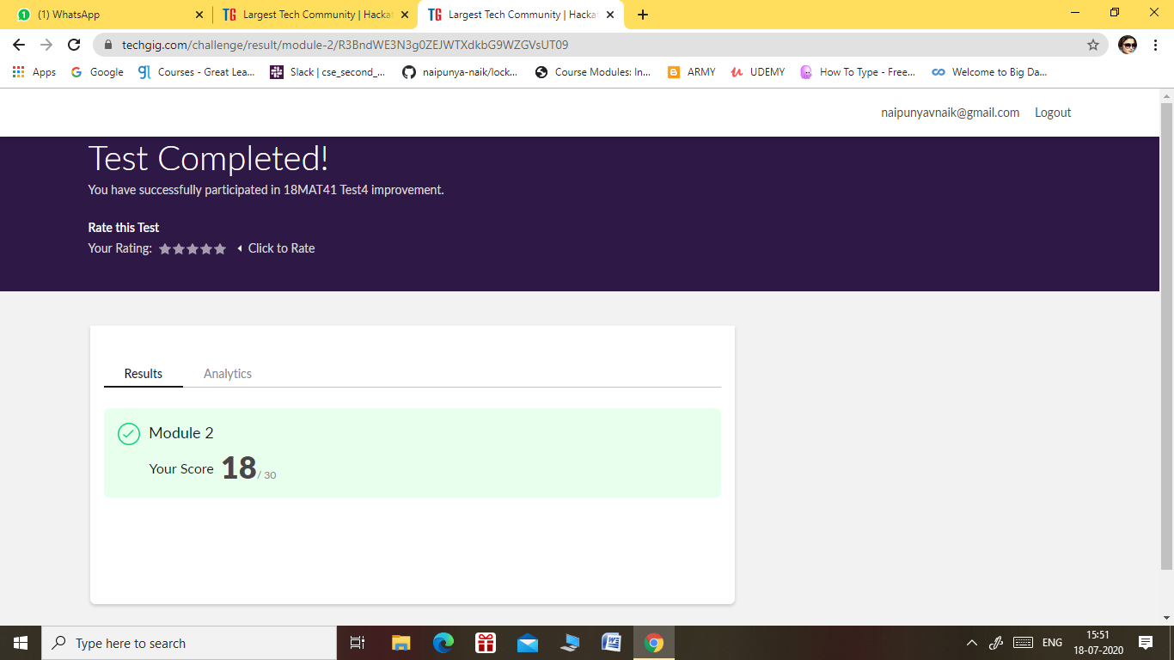

2)

* THE MATHS IMPROVEMENT TEST_2 WAS CONDUCTED ON 18 JULY 2020
* SYLLABUS:- MODULE 3
* NO OF QUESTIONS:- 10
* TOTAL MARKS:- 10
* EACH QUESTION CARRIED 1 MARK
* TEST DURATION:- 1.5 HRS
* FROM 3 TO 4.30 PM
* I SCORED 7/10 MARKS IN THE TEST
* THE SNAPSHOT OF THE RESULT IS CURRENTLY UNAVAILABLE.
* 3) THE MATHS RE-IMPROVEMENT WAS CONDUCTED ON 18 JULY 2020
* SYLLABUS:- MODULE 3
* NO OF QUESTIONS:- 20
* TOTAL MARKS:- 30
* THE TEST COMPRISED OF TWO TESTS, TEST 1 AND TEST 2.
* TEST 1 COMPRISED OF 10 QUESTIONS
* EACH QUESTION CARRIED 2 MARK IN TEST 1
* TOTAL MARKS IN TEST 1:-20
* TEST 2 COMPRISED OF 10 QUESTIONS
* EACH QUESTION CARRIED 1 MARK IN TEST 2
* TOTAL MARKS IN TEST 2:- 10
* TEST DURATION:- 1 HR
* TOTAL MARKS IN TEST 2:-10
* FROM 4 TO 5PM
* I SCORED 10/20 MARKS IN THE TEST 1, I SCORED 6/10 IN THE TEST 2.
* THE SNAPSHOT OF THE RESULT IS CURRENTLY UNAVAILABLE.

Certification Course Details: (Attach the snapshot and briefly write the report for the same).

1. CERTIFICATION COURSE NAME:- **THE ABSOLUTE BEGINNERS GUIDE TO CYBERSECURITY PART-1**

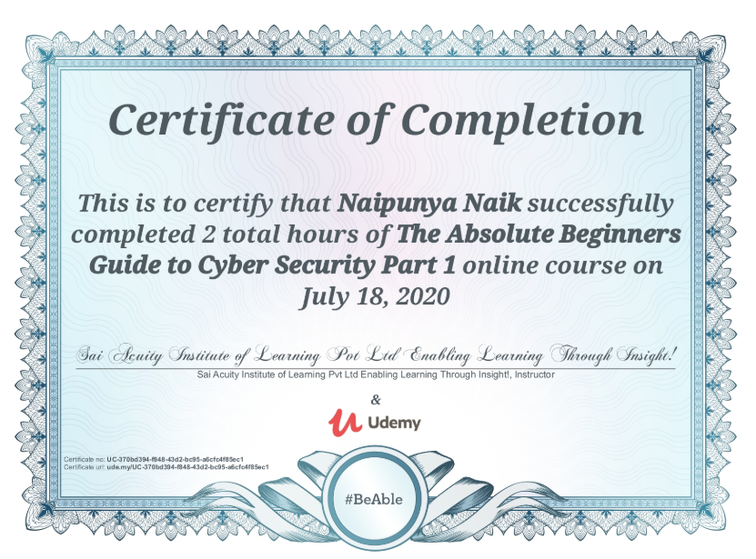

2)CERTIFICATION COURSE NAME:- **LEARN R-PROGRAMMING FOR MACHINE LEARNING AND DATA SCIENCE**

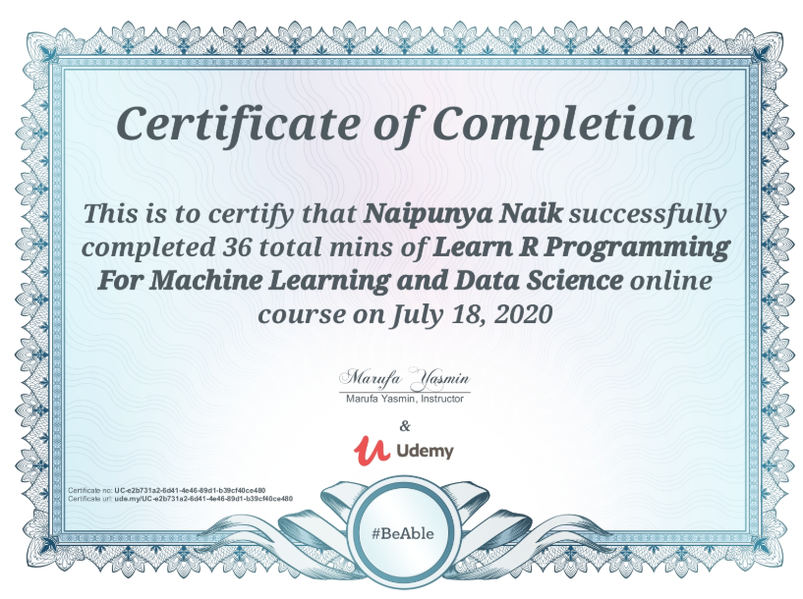

**3)CERTIFICATION COURSE NAME:- ANDROID MALWARE ANALYSIS FROM ZERO TO HERO**

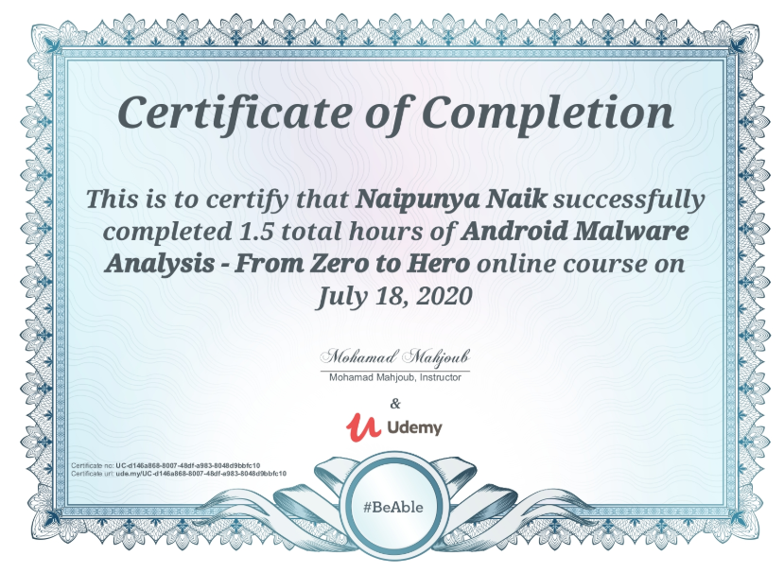

**4) WEBINAR ON BLOCKCHAIN TECHNOLOGICAL-PERSPECTIVE**

**CONDUCTED BY BVICAM , NEW DELHI**

* **DURATION 2 HRS**
* **FROM 4.30 PM TO 6.30 PM**

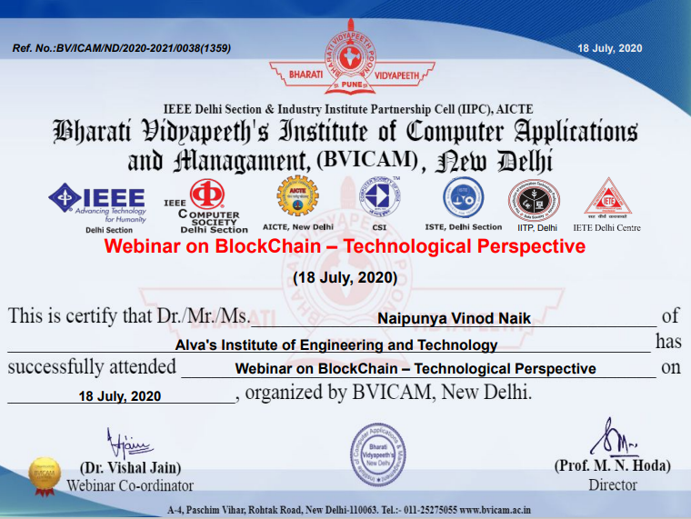

5) CERTIFICATION COURSE NAME:- **GOOGLE CLOUD PLATFORM BIG DATA AND MACHINE LEARNING FUNDAMENTALS**

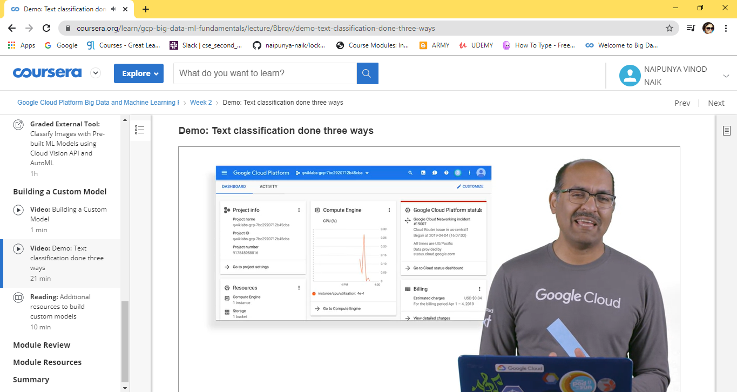

Coding Challenges Details: (Attach the snapshot and briefly write the report for the same).

PROBLEM STATEMENT:- [Reverse words in a given String in Python We are given a string and we need to reverse words of given string ?](https://github.com/orgs/alvas-education-foundation/teams/2nd-year/discussions/151)

Top of Form

Bottom of Form

|  |
| --- |
| Examples: Input : str = "AIET CHALLENGES IIT" Output : str = "IIT CHALLENGES AIET" |

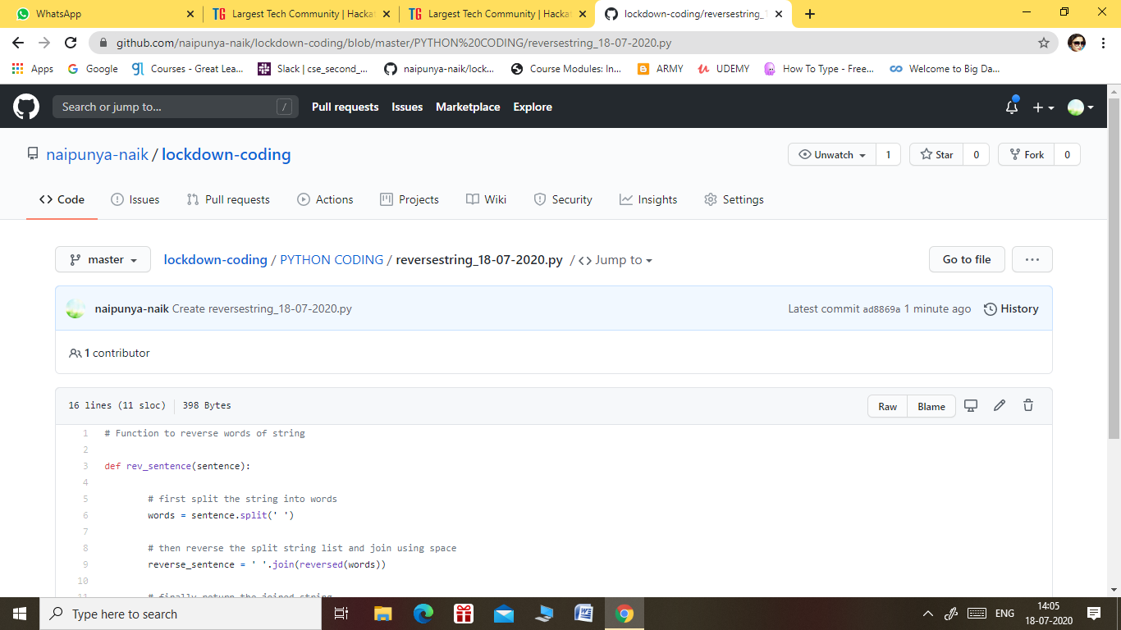

GITHUB REPOSITORY LINK:-

<https://github.com/naipunya-naik/lockdown-coding/blob/master/PYTHON%20CODING/reversestring_18-07-2020.py>